St. John AME (Nashville) credits their time and experience in the ABC|CLMPI’s discernment and design-thinking centered process with supporting them in revisiting their ministry plans with the Holy Spirit after the March 3, 2020, Nashville destroyed their historic church building. And they share powerful testimony on why it's important in serving as the church to remember that we are the church, not the building, and that, disaster or no, we should remain in faithful and continual process of realigning in our vision with God.
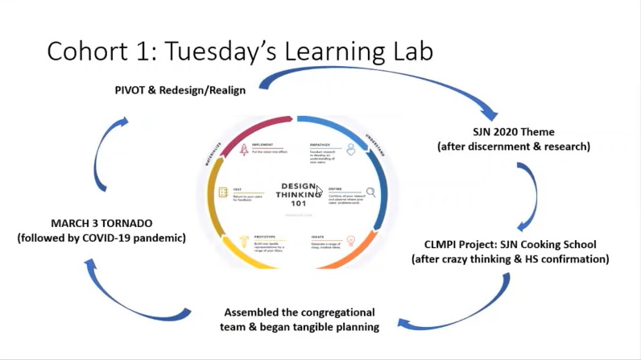
The design thinking process encompasses so much of what St. John AME has experienced working through the effects of the tornado and the onset of COVID-19. After a few years of discernment and research, the congregation was poised to open a cooking school in their church building for youth in the neighborhood. The cooking school would have served as both training for the youth to work in restaurants, and to help them connect with available jobs.
Original design thinking model courtesy of the Nielsen Norman Group
St. John AME had begun planning, assembled a team of community partners, and was preparing to submit their grant application to ABC|CLMPI when a tornado swept through Nashville on the evening of March 3, 2020. Their neighborhood was devastated, and the congregation’s building—home of the Mother AME church in Tennessee, originally built on Capitol Hill in Nashville—was declared a total loss.
Discernment and design thinking have helped them to “pivot” and rethink how they are called to serve—immediate community needs, as well as reorienting their original vision such that they are building new community relationships and partnerships in order to fulfill it. Some powerful summary lessons and thoughts from the congregation in their process:
- Trust God in it all. It may seem overwhelming to have to pivot, pivot again, and pivot some more. Trust God.
- Trust the design process, and the people in it. It works. There is a point where it will click.
- Lean into and embrace the uncertainty—and strive to be okay with it. This is hard for those of us who like to plan our work and work our plan. But something can happen to the plan—a tornado, COVID-19, all kinds of other things. This is going to be hard, but do the best we can to be okay with it, because where we are is where we are.
- Press forward with holy anticipation and excitement for next steps. Be more willing to look forward to what God has for us, than to look back at what we had. God has promised that our latter will be greater than our former. Believe that this is where pivoting with the Holy Spirit is taking us— forward to our greater, not back to “what we were.”

- Pay attention to your discernment.
  - Not all money is good money, and not all productivity is beneficial. There were a lot of people who wanted to help, but what they wanted to do or give was not in alignment with what we needed or where we were headed.
  - Beware of people who are trying to tell how to do what God has already told you to do, and present themselves as higher than the Lord.
- Be open to the move of God in whatever method it arrives. God manifested Themselves in a variety of ways in the resulting four months since the tornado and the onset of COVID-19.
For more detailed information, you can view Pastor Lisa Hammond’s powerful presentation at our July 2020 Summer Institute.

